Salweyar Patel

**Scratch Project – Self Evaluation**

Required Features: General Requirements

1. Decision blocks are used to control the flow of your program.
2. For giga walking: this sprite is the main sprite where it contains all the decision blocks to save princess.

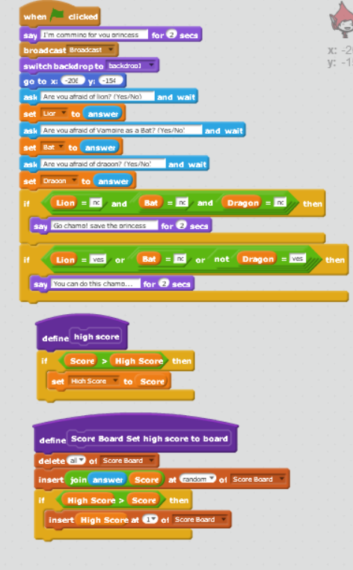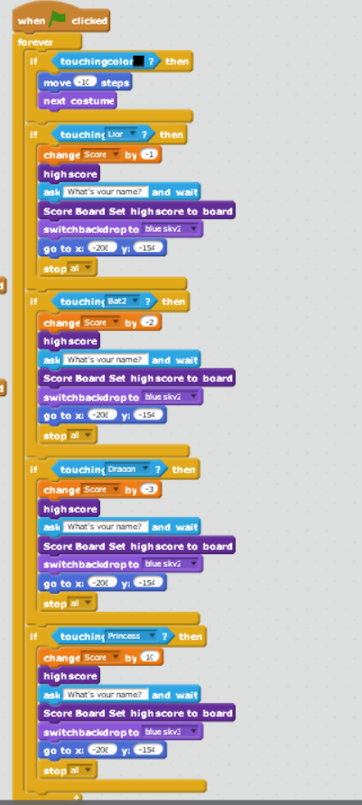

1. For lion: it is an obstacle to hinder the main sprite and the decision block is using to move random in the specific place.

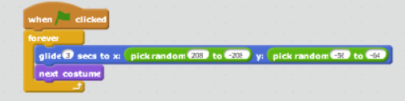

1. For vampire as bat: it is an obstacle to hinder the main sprite and the decision block is using to move random in the specific place.

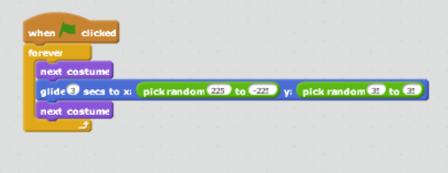

1. For dragon: it is an obstacle to hinder the main sprite and the decision block is using to move random in the specific place.

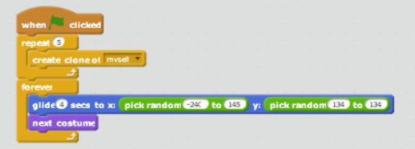

1. For princess: decision block is use to show that the princess is save.

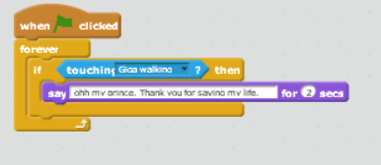

1. At least two Boolean operators (and, or, not, >, <, =)  are used in conjunction with decisions to control the flow of your program.

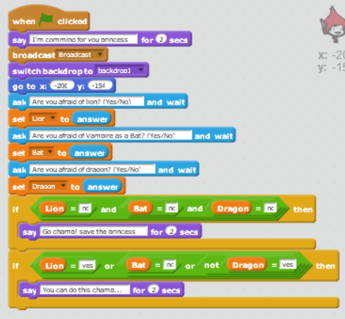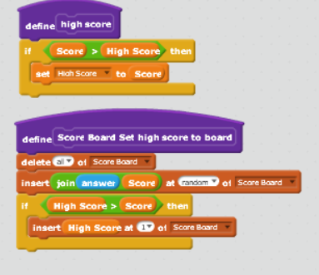For giga walking: Here the Boolean operator are use to guide and encourage you to make the game fun as well as set high score.

1. Input is gathered from the user using the "ask" block, stored in custom variables, and the user's responses are used later in the program.

For giga walking: three questions are ask to make the game little interesting and answer are store in variable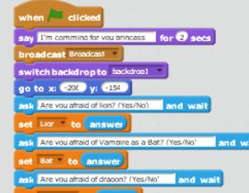.

1. User input is used to control the movement of a sprite.

For giga walking: here the left/right/up/down keys allow user to move sprite.

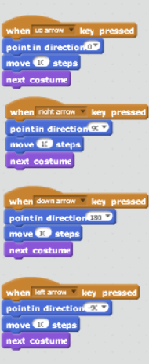

1. User input, which has been stored in a variable, is used with a decision to control the flow of the program.

For giga walking: The values which are store before in program are now use by the sprite to say something to the player.

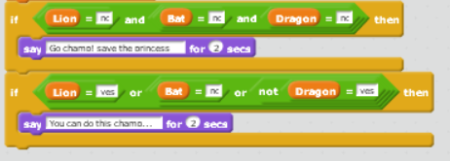

1. At least two variables are used in your program.

For giga walking: here are the two variables(score/high score) which are use to show score for the player who is playing.

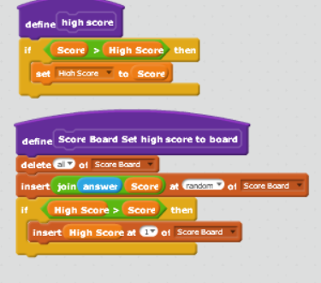

1. At least two sprites are used, both sprites having different scripts that control them.

There are five sprites use in the game as shown below.

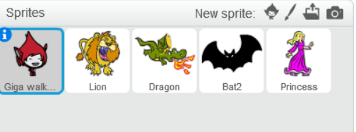

For giga walking: this is the code for giga as prince to save princess and the score is recorded.

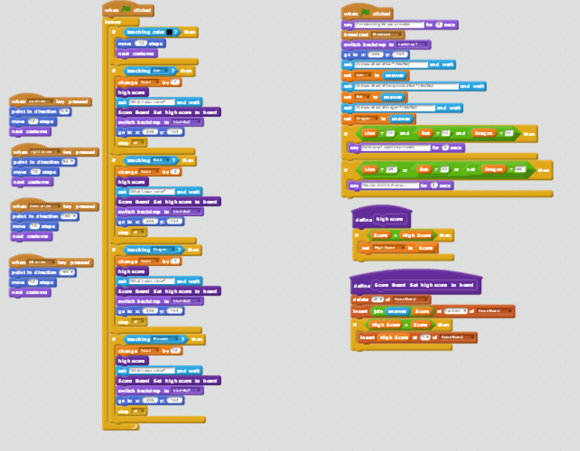

For lion: this is the code to move lion around its path.

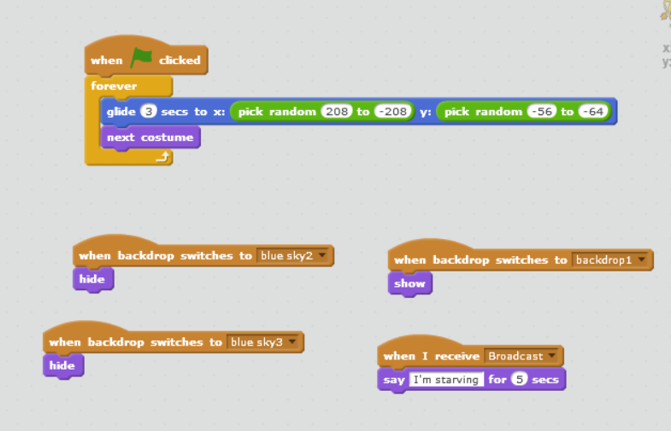

For vampire as bat: this is the code to move bat around its path.

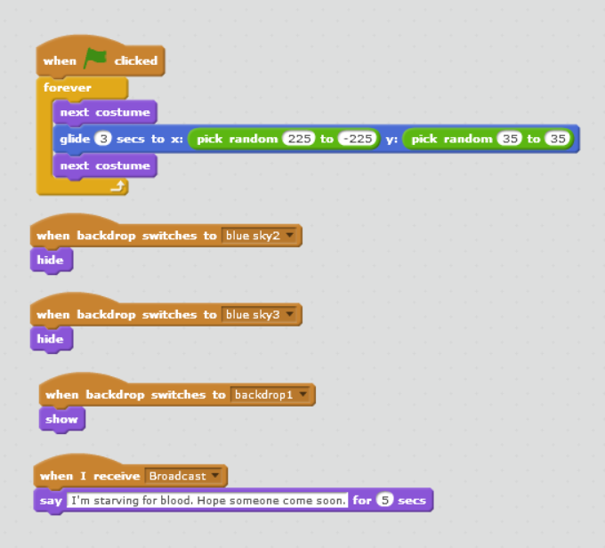

For dragon: this is the code to move dragon around its path.

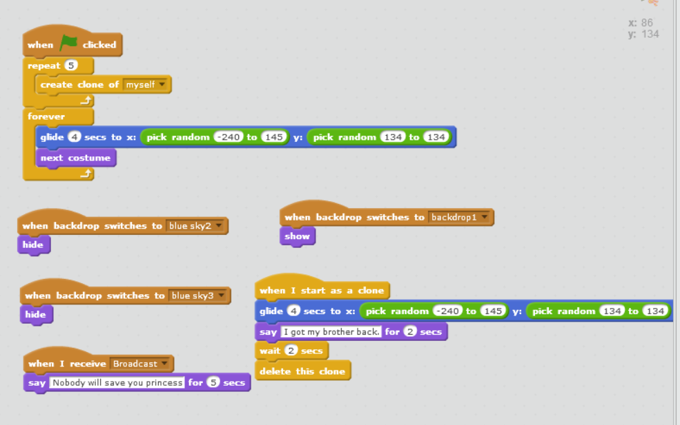

For princess: this is the code where princess say something when she has been saved by the prince as giga

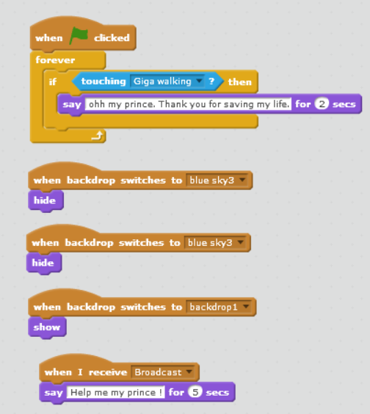

1. At least one list is used in your program. This list must be used to store a collection of related things. For examples, a high score list, a list of musical notes to play, a list of costume numbers to animate through, etc.

In giga walking: here is the list in the game to store score and high score.

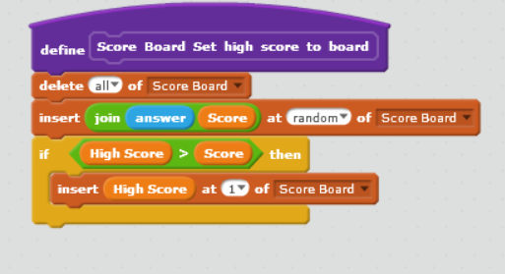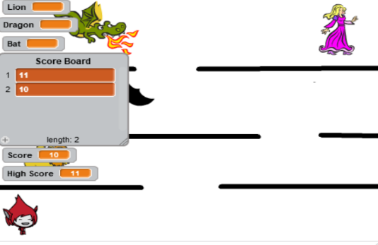

1. More than one backdrop costume is used for the stage.

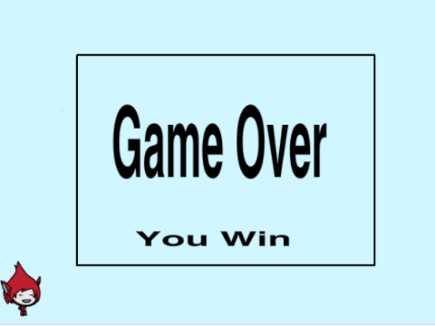here are the three backdrop used in program.

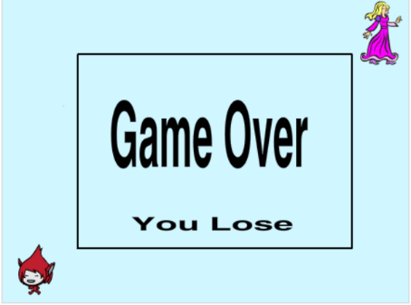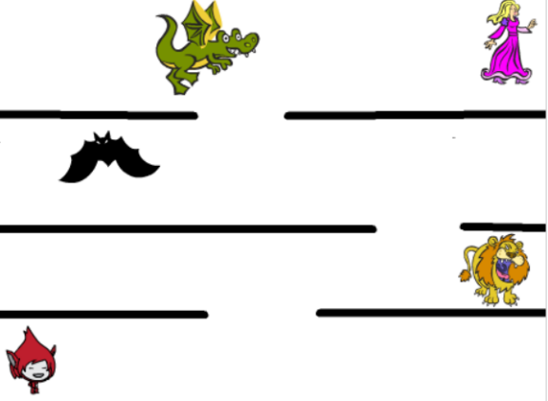

Required Features: Advance Requirements

1. A broadcast message is sent by one (or more) sprite(s). This message is received and acted upon by one (or more) sprite(s).

For Lion: when lion receive the message by giga then it says something in project.

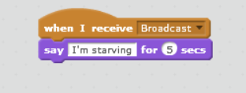

For giga walking: this is the main sprite that broadcast the message to all the sprite in the game.

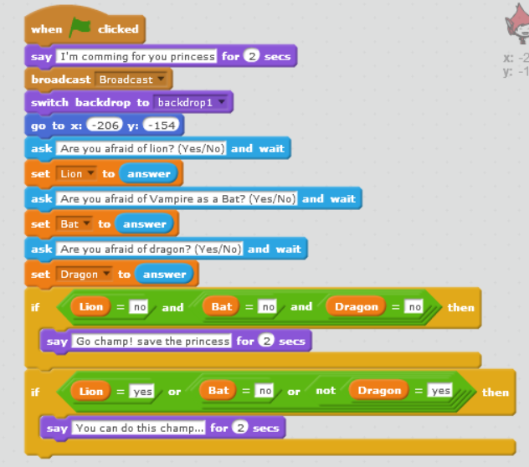

For vampire as bat: when bat receive the message by giga then it says something in project.

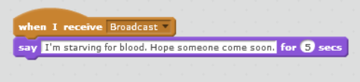

For dragon: when dragon receive the message by giga then it says something in project.

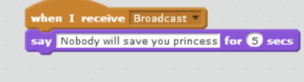

For princess: when princess receive the message by giga then it says something in project.

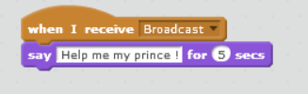

1. You defined a custom block (dark purple "More Blocks"). You must use this custom block at least twice in your project. Your created block must be built out of at least three blocks.

In giga walking: there are two blocks created and used in program.

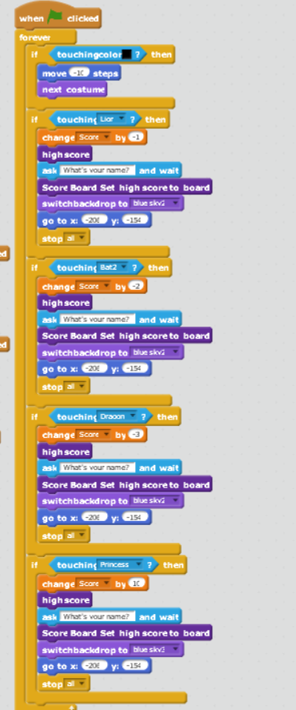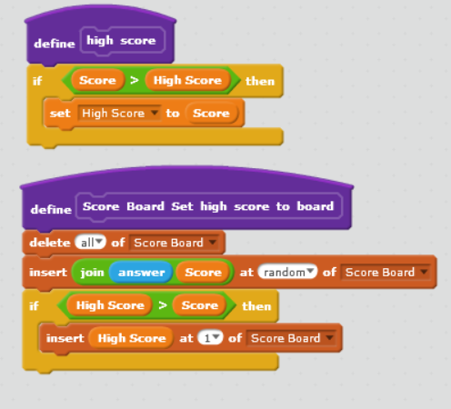One which says high score is the block to set high score in high score variable whereas other which says score board set high score to board is the block which set the high score in the list as higher to lower number.

1. One of your sprites must be controlled by the orange "When I start as a clone" block.

For dragon: here is the code where dragon make its clone and display some message to the prince.

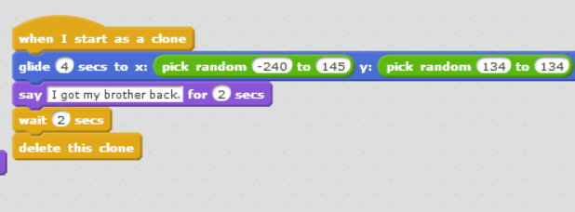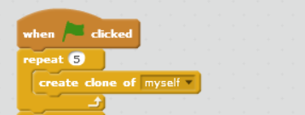

1. EXTRA ADVANCED: You've used a list sorting algorithm somewhere in your program. For example, for a high score leaderboard that is always sorted from high to low scores as new scores are added.

For giga walking: here is the code where two custom blocks is created where it set the list score board to display higher to lower numbers.

